# Syncfusion Dashboard Cloud

Syncfusion Dashboards is a cloud-based software-as-a-service offering that allows you to easily create and share business dashboards.

## Create a free subscription account

1. Go to the link - <https://app.syncfusion.io/bi/register>

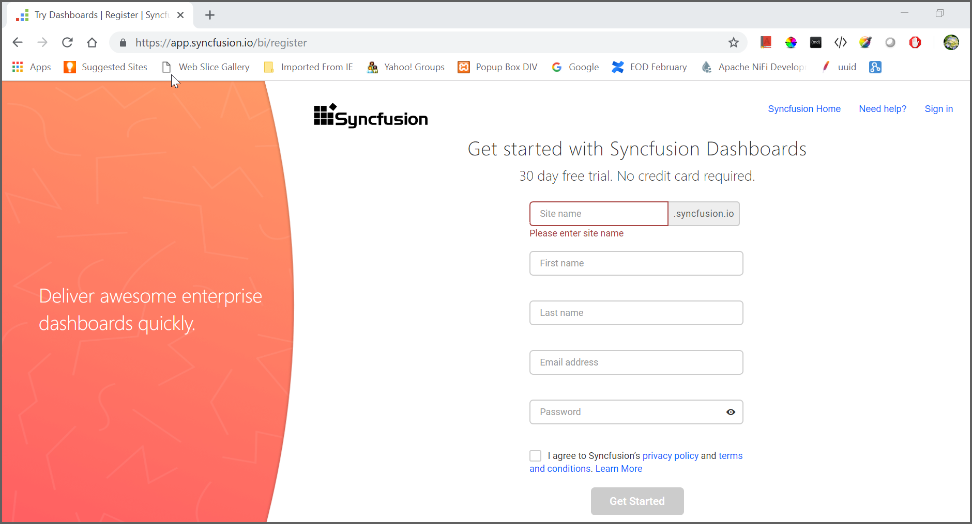

2. Enter the credentials and click Get Started button to start creating dashboards. Once logged in, you can see browser as below:

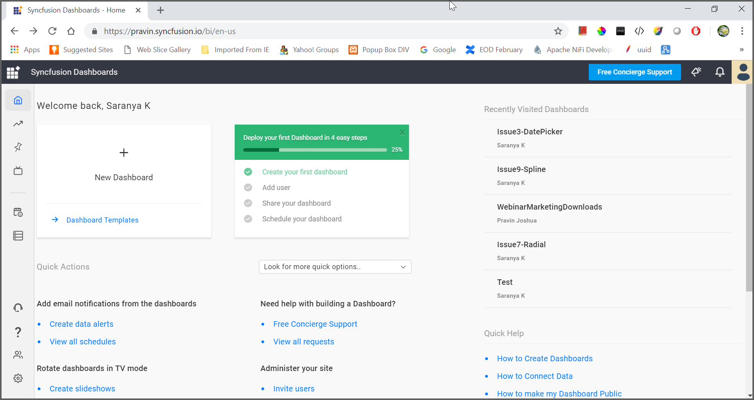

Left side menu’s:

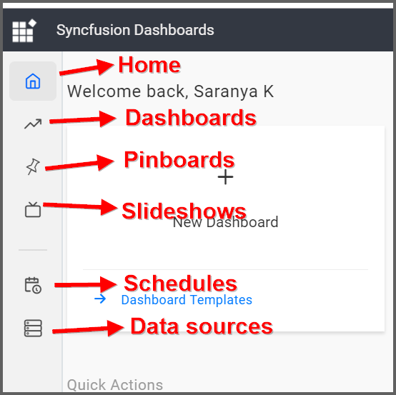

## Working with data sources:

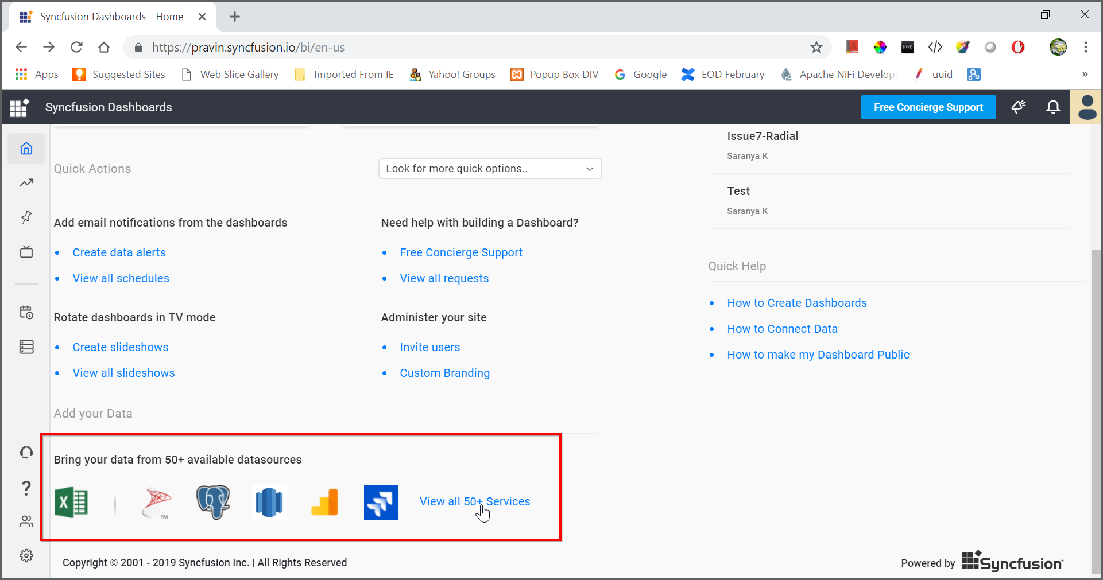

Once you click the View all option, you can see all the available data sources as below:

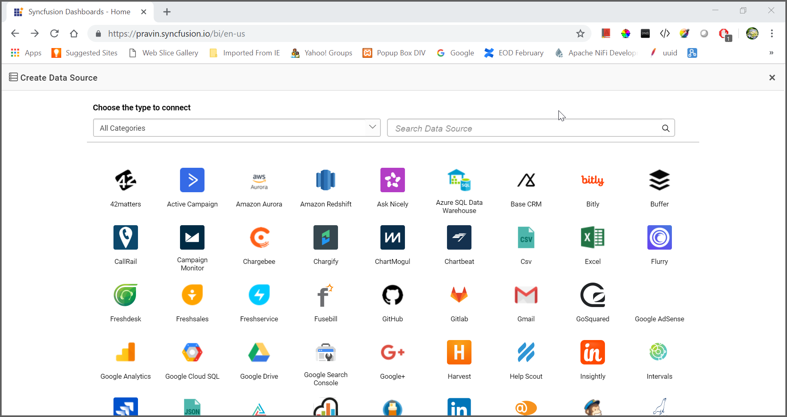

For example, add excel data source using local file,

Choose excel data source:

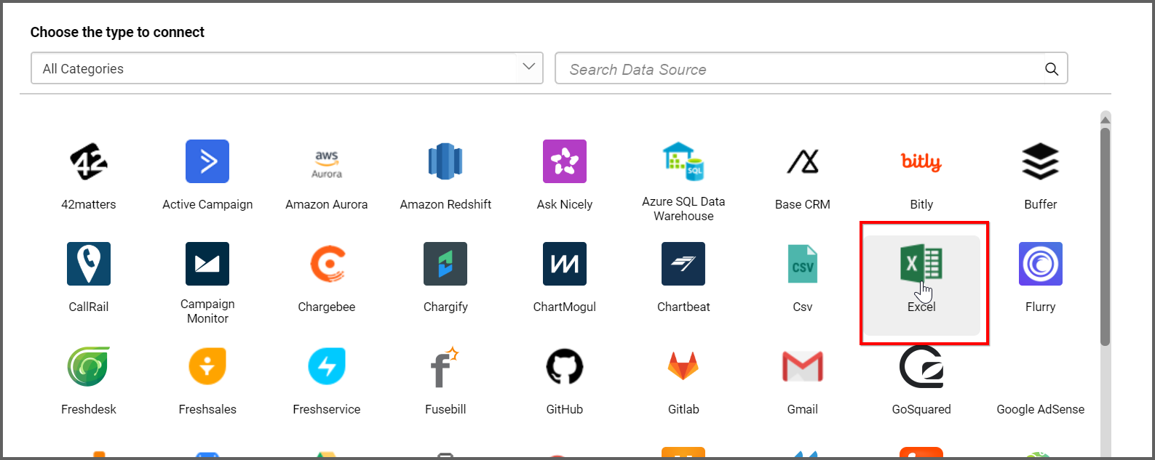

Click preview and connect:

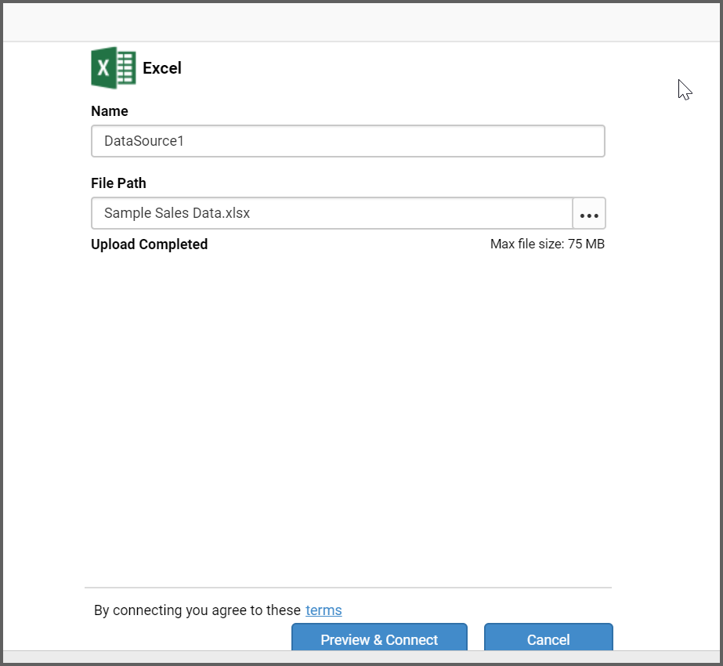

Preview the data and click Connect button:

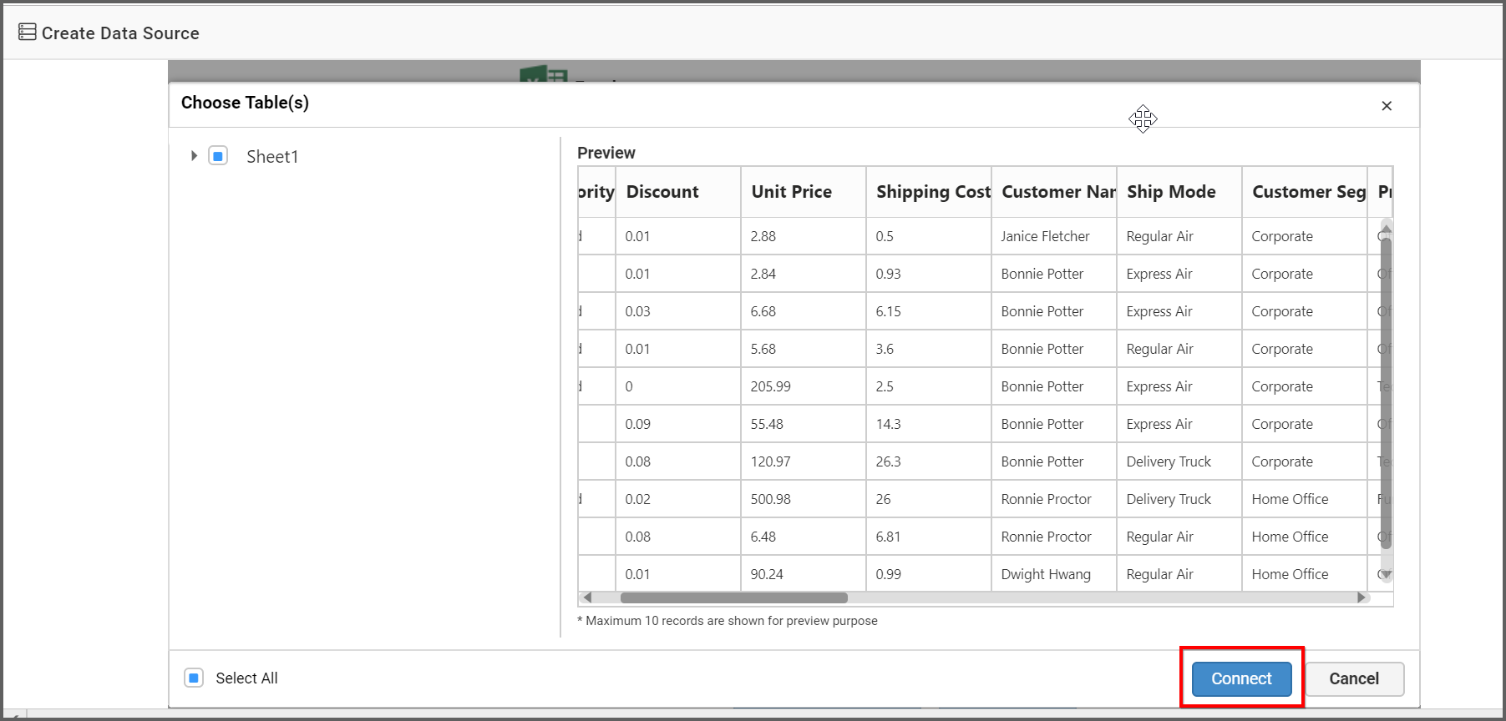

Drag the sheet and drop into the canvas. Edit the data source if needed and click Save and Exit button.

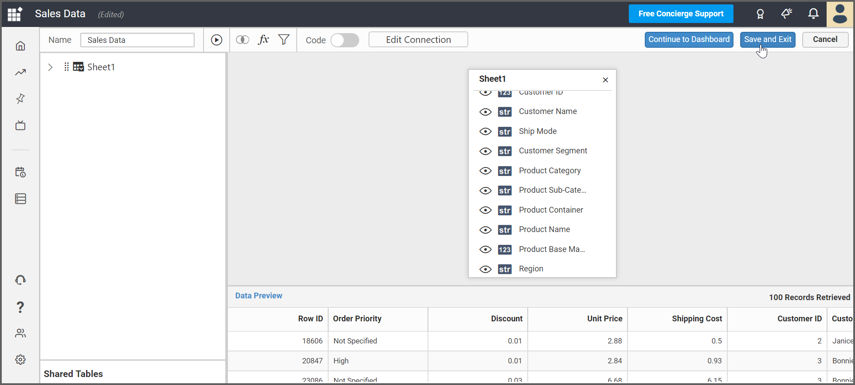

Now the created excel data source will be added into the data sources list:

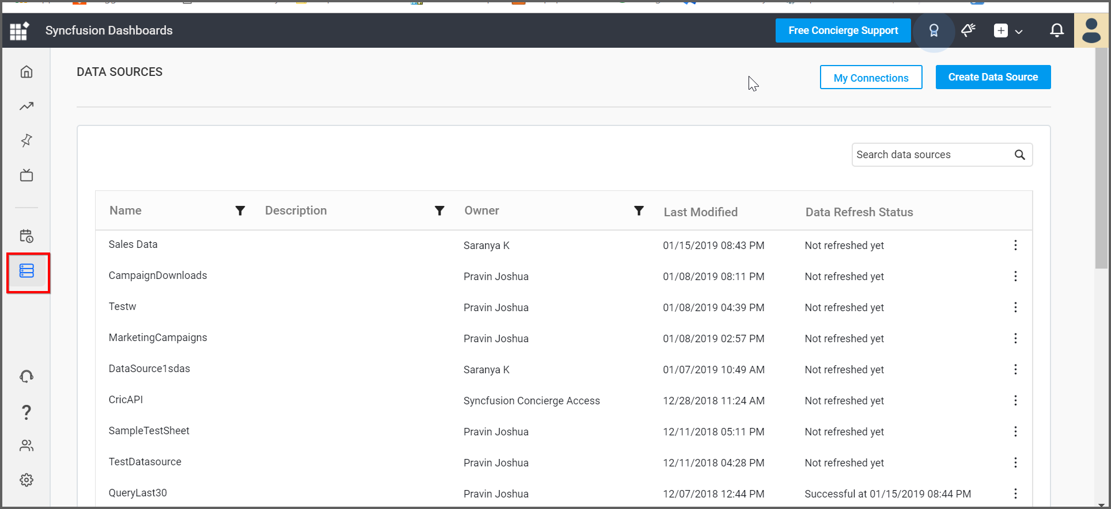

## Create a simple dashboard

Click the Dashboard option on the top right corner Add icon:

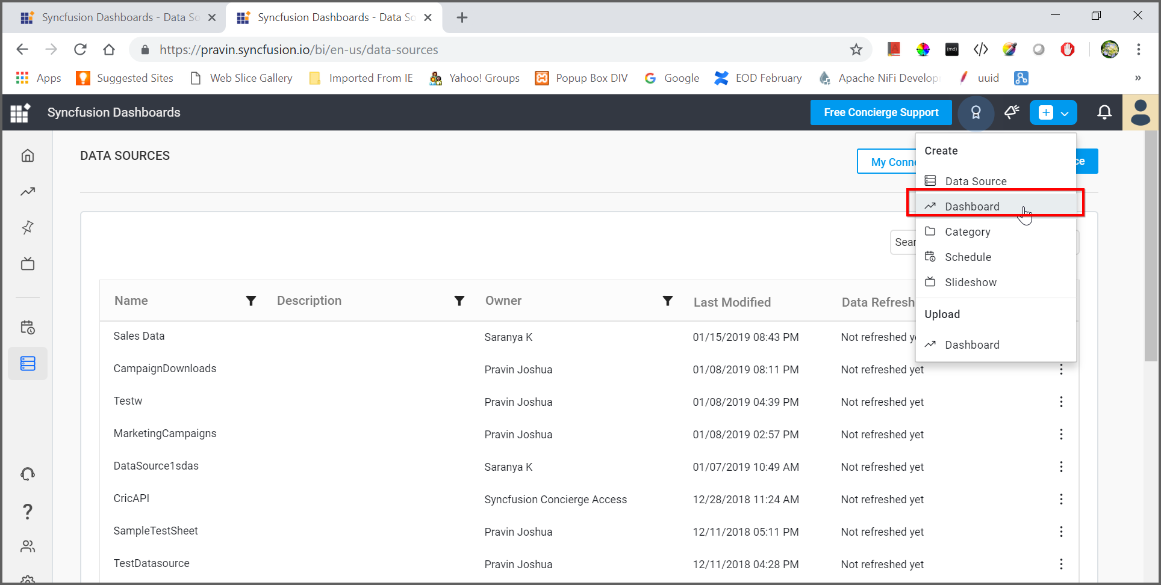

Click Blank Dashboard and the Dashboard Designer will be opened:

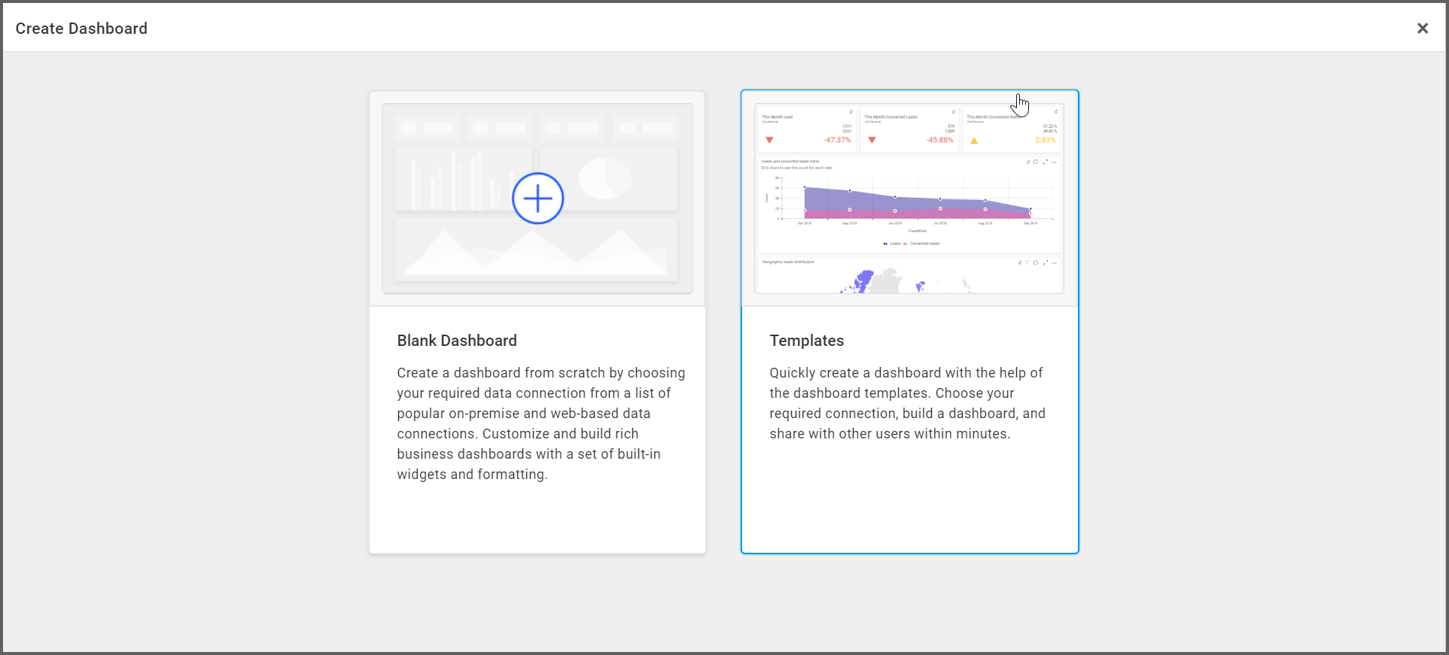

Dashboard designer canvas will be rendered:

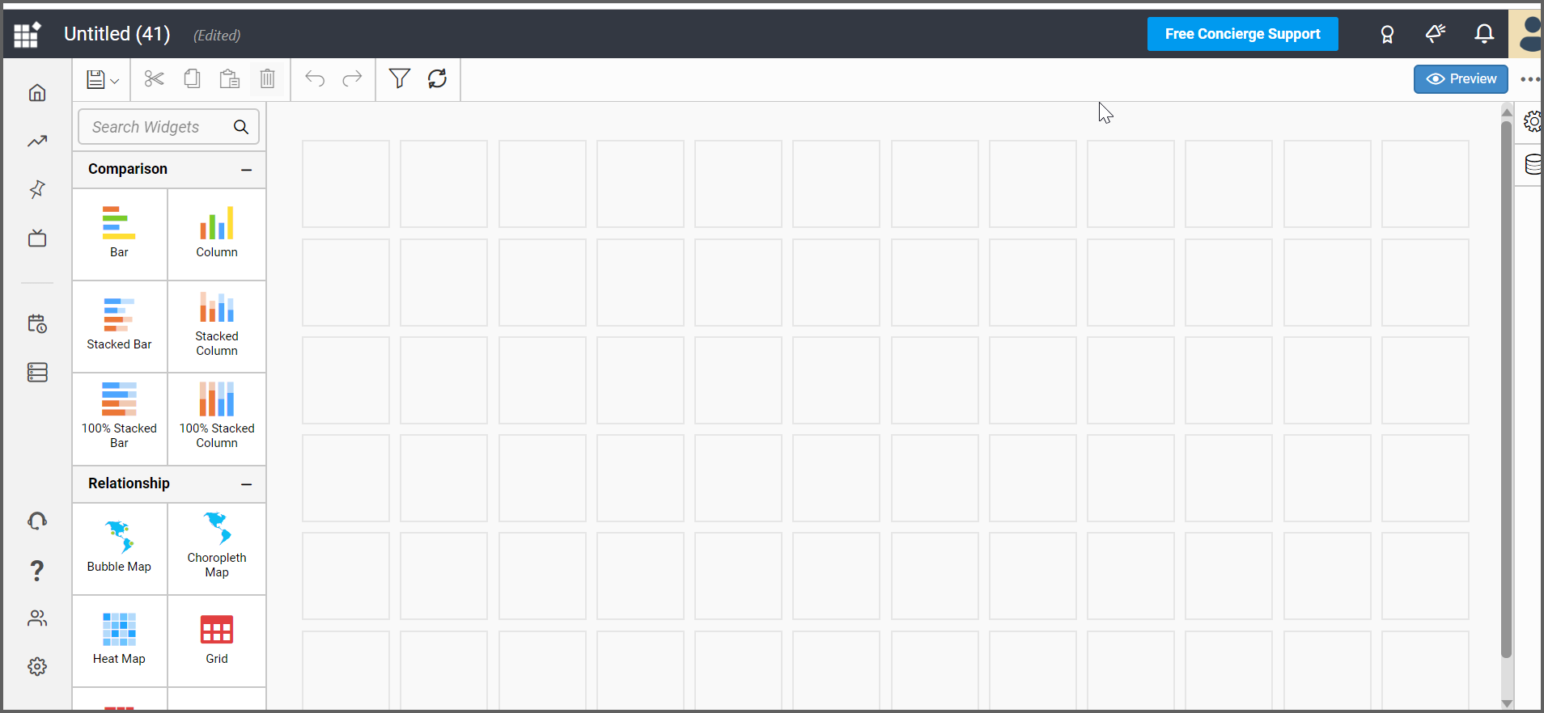

Let’s start to create the dashboard similar to the Sales Dashboard as below:

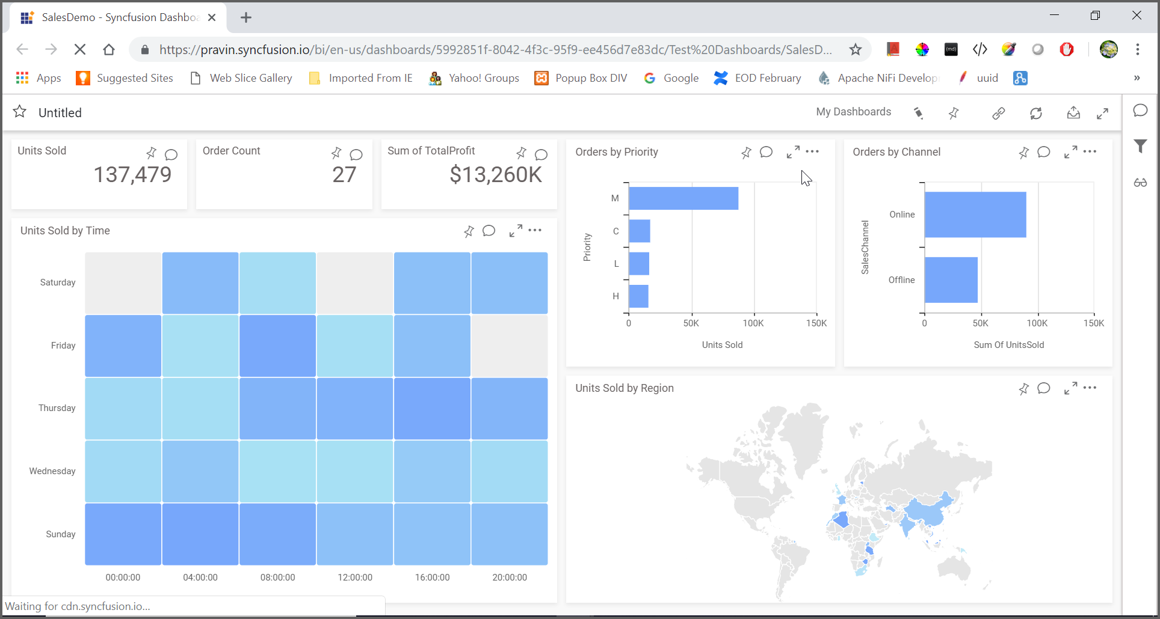

Drag and drop the Card widget from the widgets into the designer canvas as below:

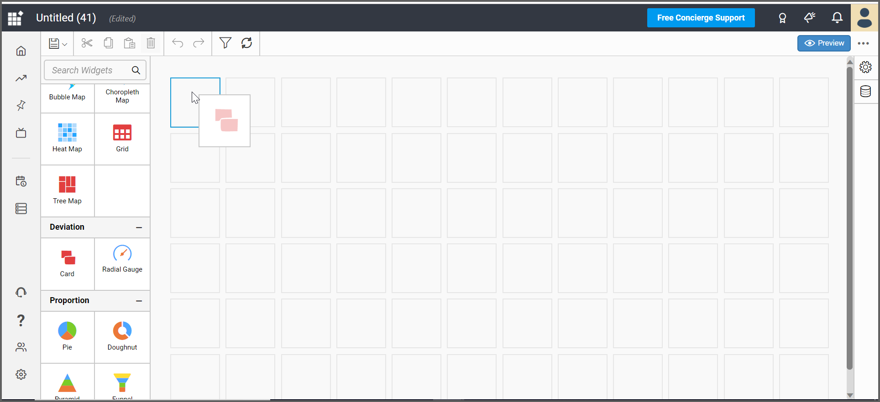

Click the Settings icon to assign data to the widget:

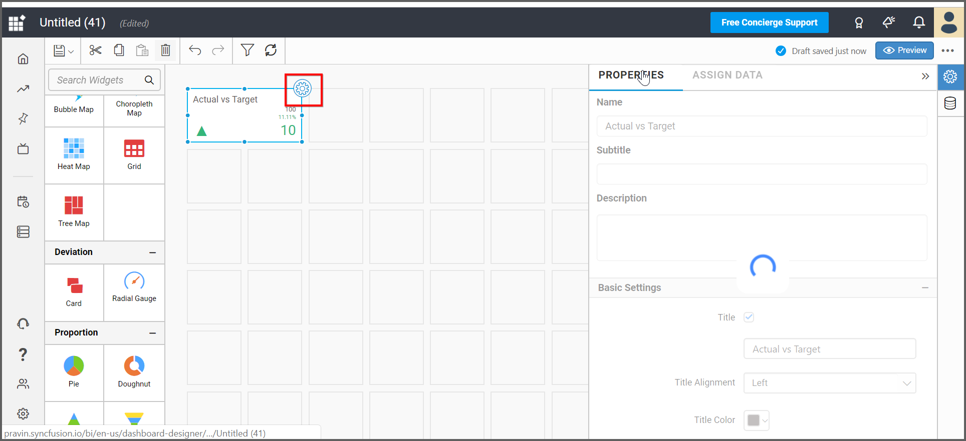

Now add the data source that we created already using excel file:

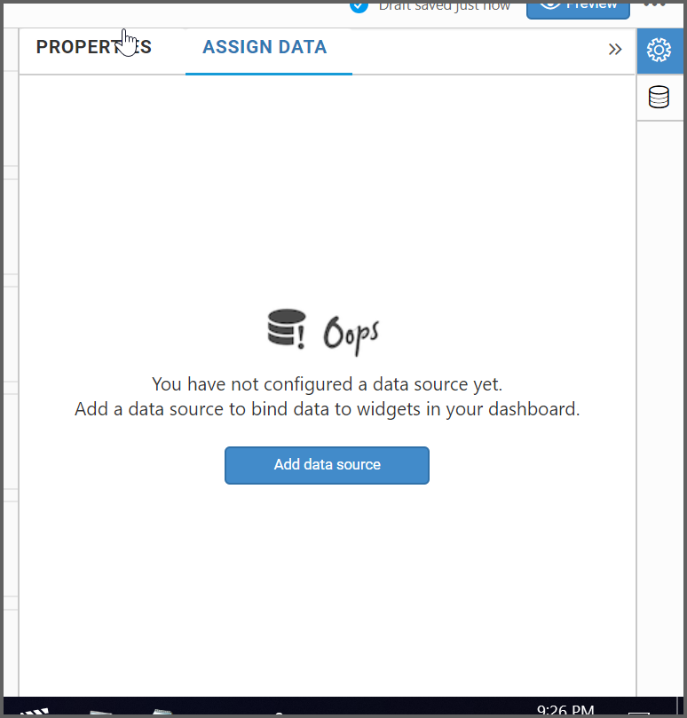

From the Use Existing option, choose the SampleSalesData as below:

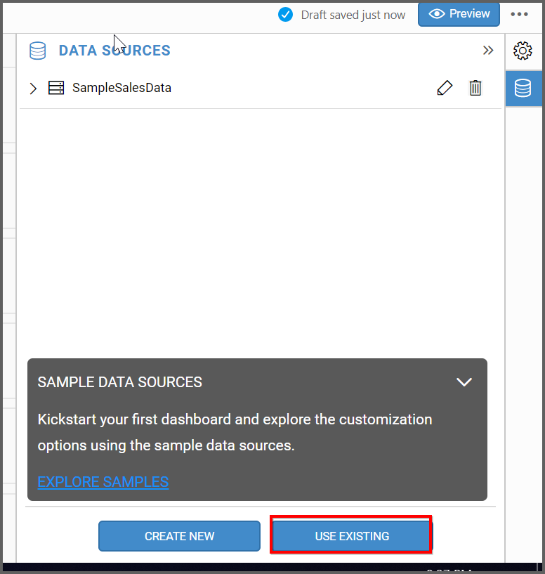

Now go to the Settings tab to assign the data:

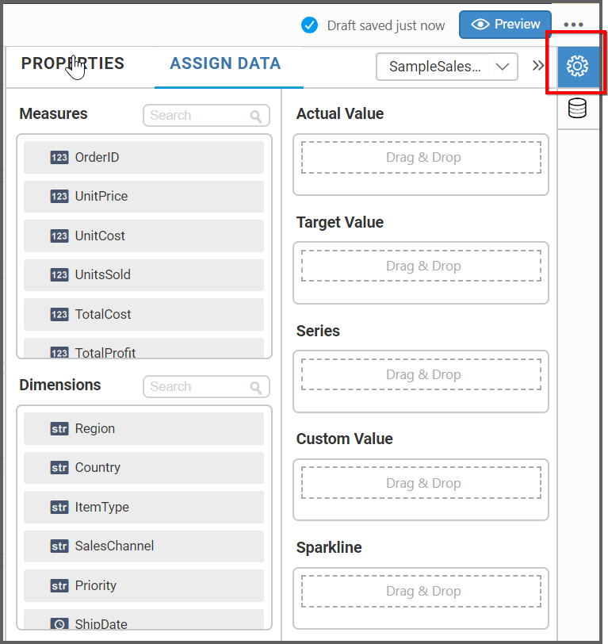

Drag and drop UnitsSold field from Measures into Actual Value:

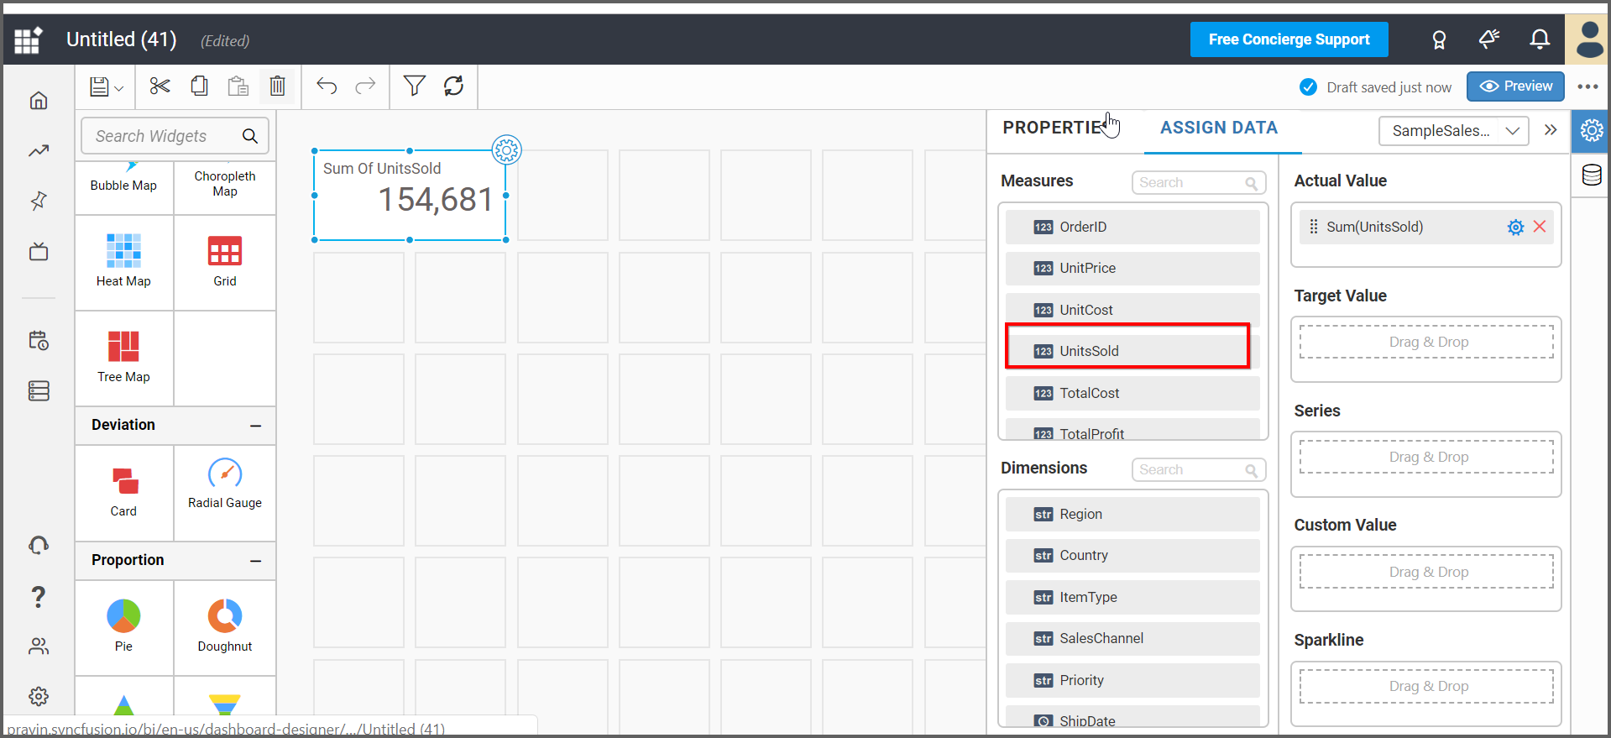

Under the Properties tab, change the name as UnitsSold. Also, you can use the options available in Properties:

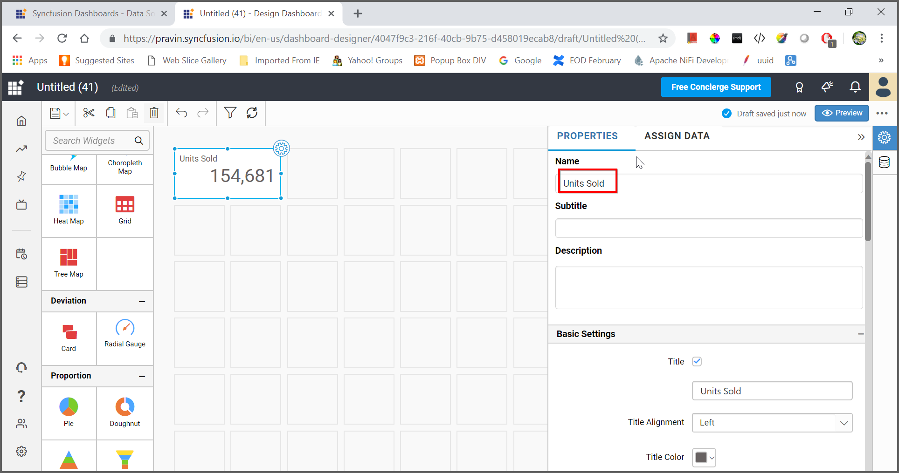

In a similar way, you can add other widgets as like Sales Dashboard. You can preview the dashboard before launching using Preview button on the top left corner:

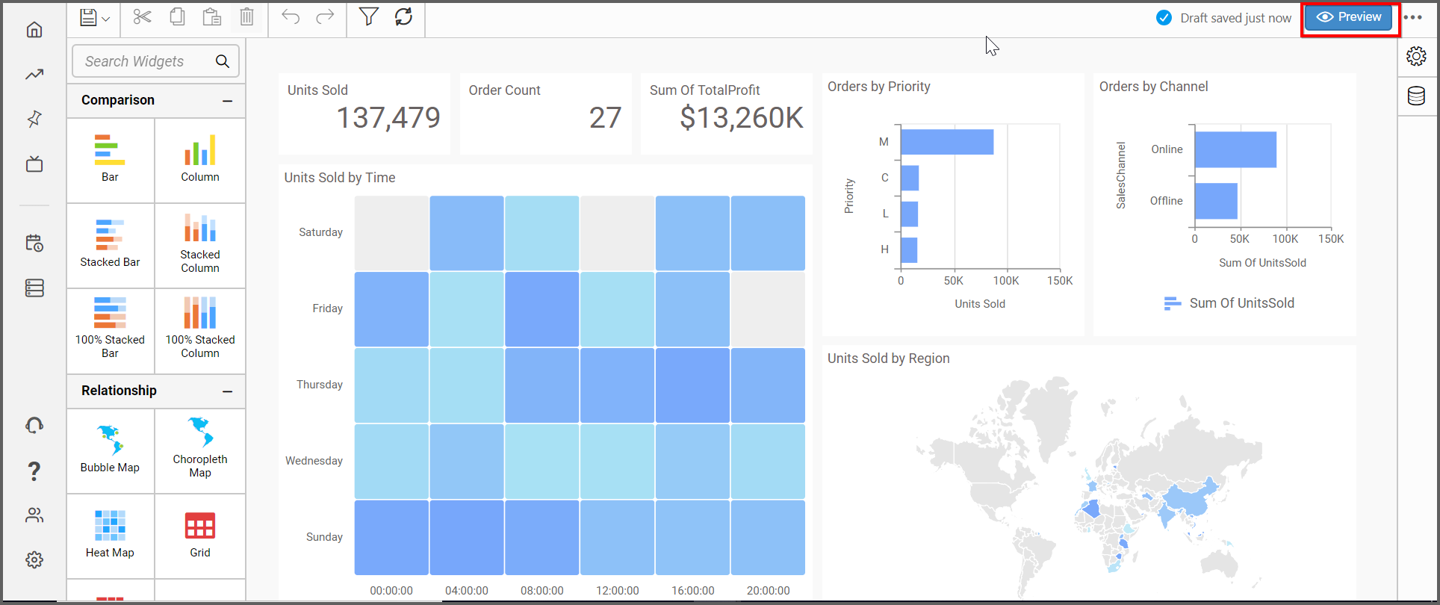

While previewing:

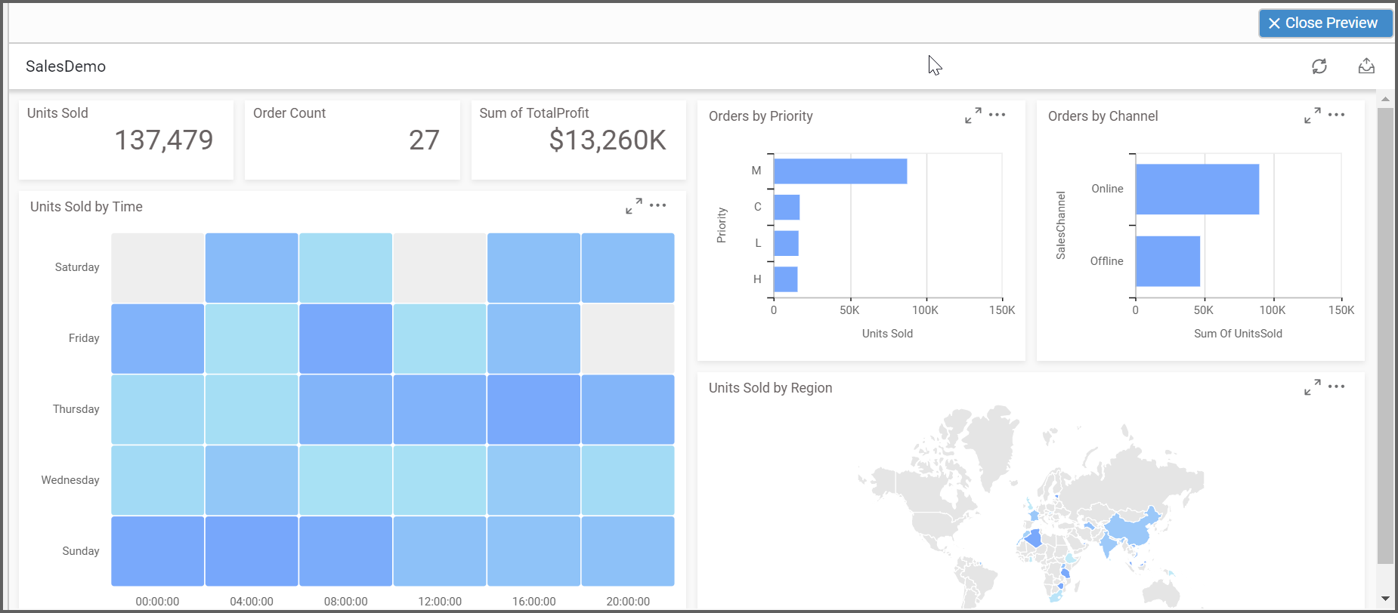

Now save the dashboard using the left corner save icon

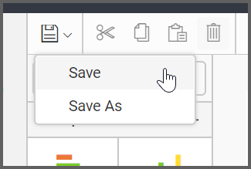

Choose or Create the Category, enter name, description and click Save button to save the dashboard.

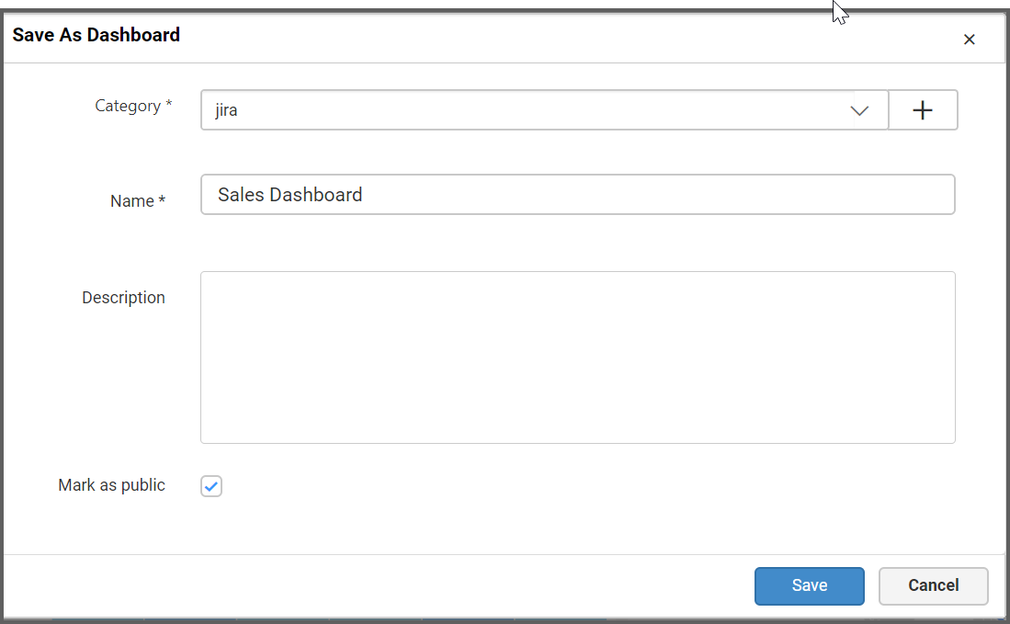

Mark as public option has been checked which we can share dashboards with other users and share it using the link of the dashboard.

Once saved, you can view the dashboard in viewer as below:

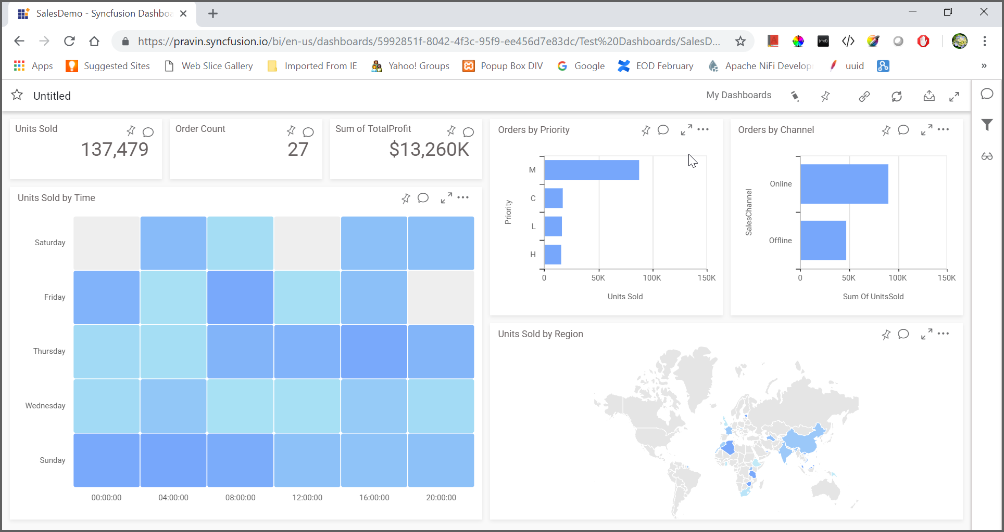

## Collaborating with other users:

You can add comment using the comment icon and collaborate with other users about the dashboard.

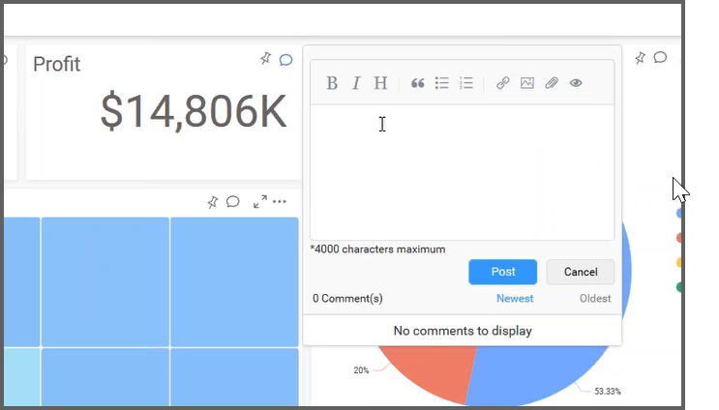

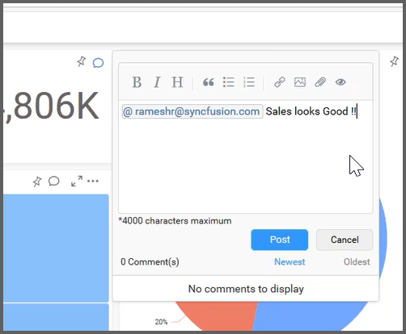

## Sharing dashboards

You can share the dashboard using the Get Link option as below:

